Framework agreement for Common IT Platform developments

- Table of contents
1. Table of contents 1
2. Introduction 2
3. Object of the tender 3
4. IT development service description 7

- Introduction
  - Purpose of the Document
This document is “Requirements Specification” (hereinafter – Specification) to the tender documents of the gas transmission and balancing services information system (hereinafter – System) additional developments for Elering and Conexus (hereinafter – Client). Specification defines and describes existing IT system technical overview and description of procured IT development service (hereinafter – Project).

  - Terms and Definitions
The key gas specific terms and IT related abbreviations used in the document are listed in the table below:

Term | Definition
Common Balancing Zone | The combined area of Estonian and Latvian natural gas balancing zones [later expected to include Lithuania and Finland]
Transmission System Operator (hereinafter TSO) | The operator of one of the national transmission systems in the Common Balancing Zone. The owners and administrators of this system.
Web Application | A software application that runs on a remote server.
Single Page Application (hereinafter SPA) | A single-page application (SPA) is a web application that interacts with the user by dynamically rewriting the current page rather than loading entire new pages from a server.
Spring Framework | The Spring Framework provides a comprehensive programming and configuration model for modern Java-based enterprise applications - on any kind of deployment platform.
Web Service | In a web service, the Web technology such as HTTP—originally designed for human-to-machine communication—is utilized for machine-to-machine communication, more specifically for transferring machine-readable file formats such as XML and JSON. All webservices in this project are implemented using the Spring framework.
Database Server | A database server is a server which houses a database application that provides database services to other computer programs or to computers, as defined by the client–server model.
Common Zone Platform (hereinafter CZP) | A set of web services, database servers, and SPAs which work together to create the Common Balancing Zone. It consists of two main systems: the BCGP-MS and the BCGP-PPS.
Baltic Gas Common Platform - Main System (hereinafter MS) | An individual system responsible for communication between Elering’s - and Conexus’s system, as well as external systems.
Baltic Gas Common Platform - Public Portal System (hereinafter PPS) | A public portal of the BCGP-MS. A separate system – for security reasons - with a separate database, web application and a single page application.
AS4 | AS4 (Application Statement 4) is an interoperability protocol that simplifies and standardizes the use of web services for business-to-business data exchange and integration.
The Time-based One-Time Password algorithm (TOTP) | An extension of the HMAC-based One-time Password algorithm (HOTP) generating a one-time password by instead taking uniqueness from the current time. It has been adopted as Internet Engineering Task Force [1] standard RFC 6238, [1] is the cornerstone of Initiative For Open Authentication (OATH), and is used in a number of two-factor authentication systems.
Identity and Access Management (hereinafter IAM) | Does authentication and authorization for applications and secure services.
Service-oriented architecture (SOA) | Service-oriented architecture (SOA) is a style of software design where services are provided to the other components by application components, through a communication protocol over a network.

  - Background
The Baltic Energy Market Interconnection Plan (BEMIP) Action Plan includes a precise task for the preparation of a regional gas market model in the Baltic States and interconnected gas market with Finland. With the establishment of the Regional Gas Market Coordination Group (RGMCG) to facilitate the development of the functioning regional gas market in the East Baltic region the countries have committed to jointly cooperate moving towards development of regional gas market.

The initial common balancing zone has been developed between the TSOs of Latvia and Estonia in 2020, with the possibility of TSOs from Finland and Lithuania joining in the subsequent years. This specification is dedicated to the additional developments of an information system where NUs can submit and manage the activities related to gas capacity bookings and nominations, receive responses from the TSO system and see the overall status of gas transmission in the common balancing zone. The development of the back-end system and data processing (common IT system is meant to collect and forward pre-processed data) is not in the scope of this specification.

- Object of the tender

System Context Diagram

The purpose of the CZP is to provide gas market related business functionality of the Common Balancing Zone to Elering (Estonia) and Conexus (Latvia), establish communication between them and external systems (other market participants), as well as provide a user interface for users of which both parties can access. The design of the system allows easy integration of TSOs of Lithuania and Finland later on, therefore having standardized technology for all parts of the system is necessary. All endpoints of the CZP must be authenticated (expect for endpoints for user authentication).

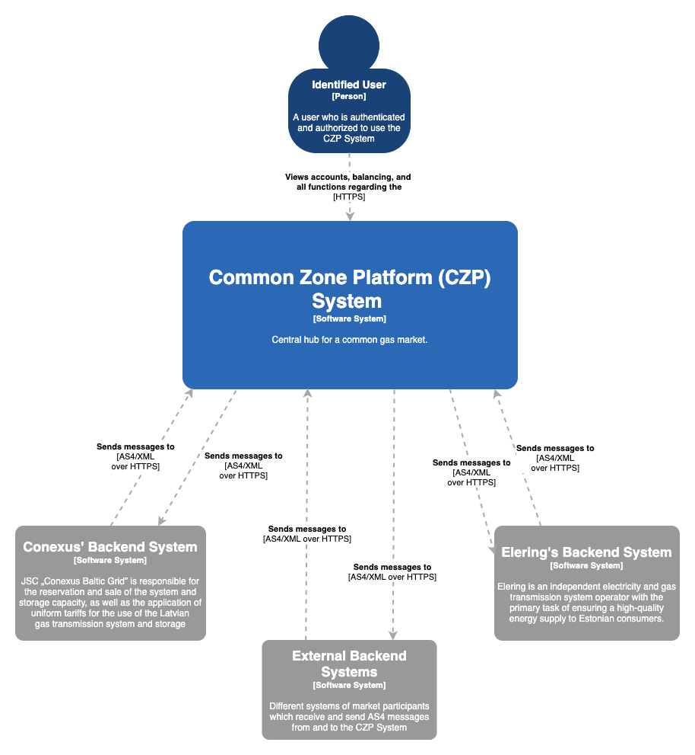

Container Diagram
The service-oriented architecture (SOA) shown on the diagram below contains components for both Human-to-Human (H2H), as well as Machine-to-Machine (M2M) communication between CZP, Elering’s Backend System, Conexus’ Backend System, as well as External Backend Systems.
The main form of communication between the parties listed is the AS4 protocol through the AS4 Gateway. The AS4 Service relays messages to the AS4 Message Broker through ActiveMQ Artemis message broker using the JMS API to the BCGP-Backend web service, where the main business logic is located. The Single-Page application of the BCGP- Backend application is served to the user through an external endpoint, the same can be said for the single-page application of the AS4-Service. For AS4 communication, IP Systems’ solution is used.
Keycloak is an open-source identity and access management tool (https://www.keycloak.org/). It supports protocols such as SAML v2.0, OpenID Connect v1.0, and Oauth v2.0 out of the box for Identity Brokering (i.e., using it with an external authentication provider). Keycloak is used as central point of authentication for H2M communication.

Disclaimer: If not mentioned otherwise, all communication between client (web browser) and web server are done with TLS (Transport Layer Security, HTTPS).

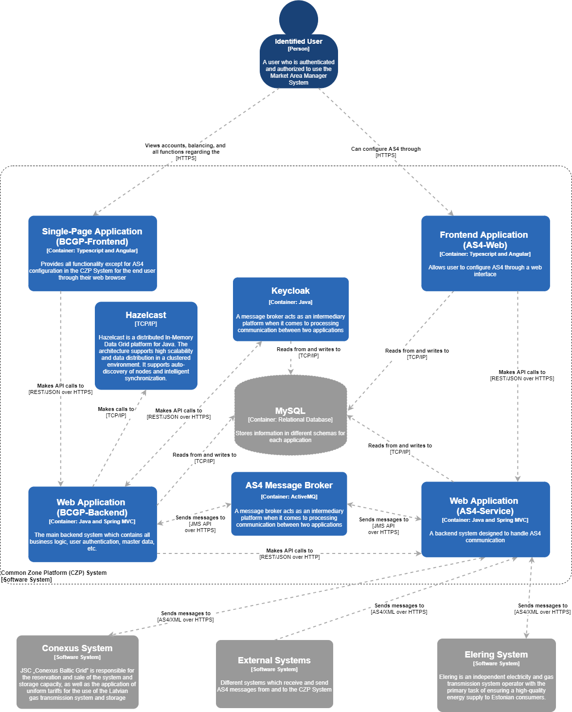

Technology Stack

Container name | Technology
Web Service (BCGP-IP) | Spring Boot, JDK, Liquibase, JPA
Keycloak | JDK
Single-Page Application (BCGP-IP) | Angular, HTML, CSS, Angular Material, Bootstrap
AS4 Message Broker | ActiveMQ-Artemis
Web Service (AS4-Service) | Spring Boot, JDK, Liquibase
Single-Page Application (AS4-Service) | AngularJS , HTML , CSS, Bootstrap
Database | MySQL Enterprise Version

2-factor authentication
2-factor authentication is required in the system, therefore, to receive the refresh and access tokens, the user has to input his/her username and password, as well the verification token generated by the Google Authenticator application for iOS or Android using the TOTP algorithm.

Logging – Elastic Stack
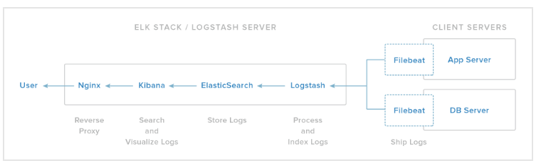

Traditionally application server logs are stored into files on the server. By using the Elastic Stack (Beats, Logstash, Elasticsearch, and Kibana), these server logs can be searched, queried, and visualized for better human consumption.

Elasticsearch: Elasticsearch is a NoSQL database. It is distributed, centrally stores your data, allows RESTful searches and this analytical engine is capable of solving different kinds of growing number of use cases.

Logstash: Logstash is the data collection pipeline tool. It collects data inputs and feeds into the Elasticsearch. It gathers all types of data from different sources and makes it available for further use.

Kibana is a data visualization tool which completes the ELK stack. The queried data can be exported in different formats such as PDF and CSV.

- IT development service description
The principles of IT system development additional services are specified under annex 1.

